$T=180°C$

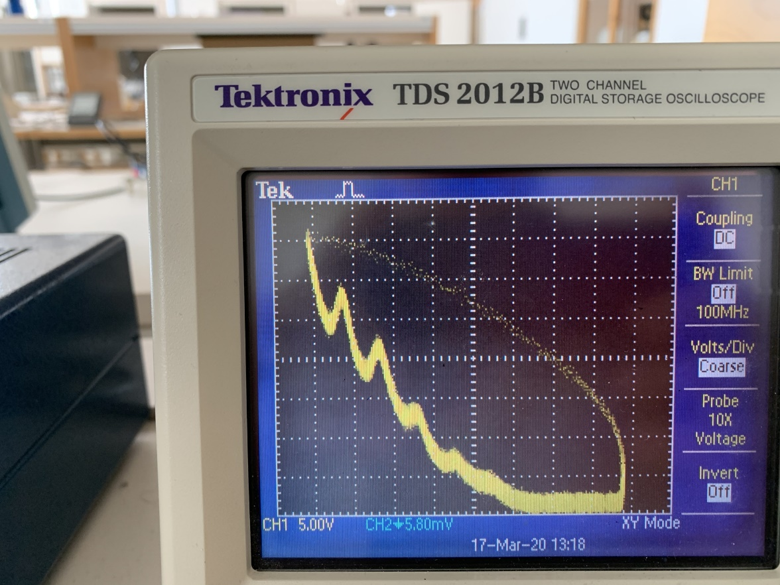

$T=160°C$

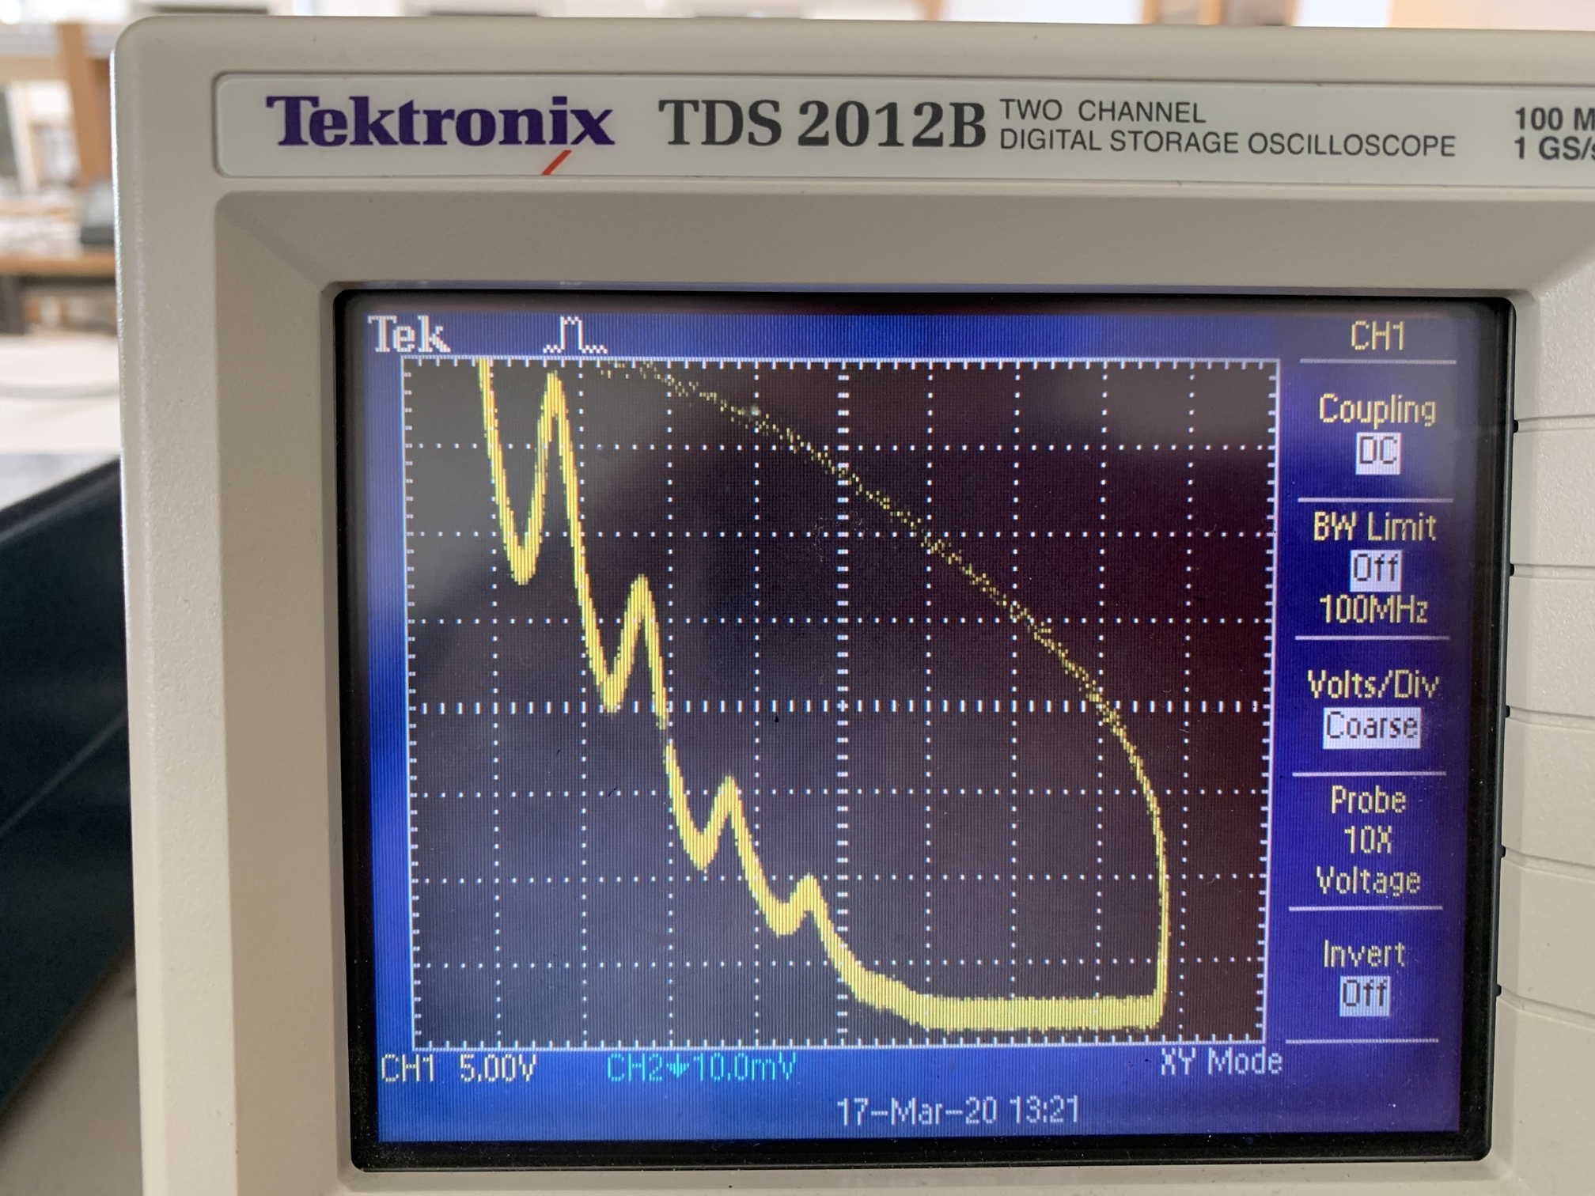

$T=140°C$

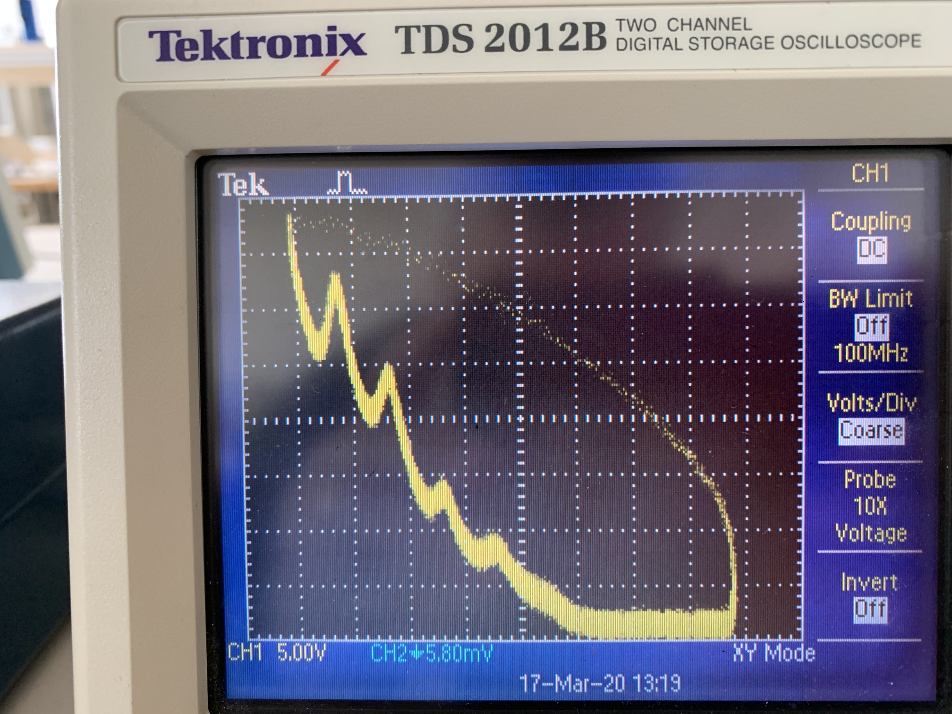

$T=120°C$

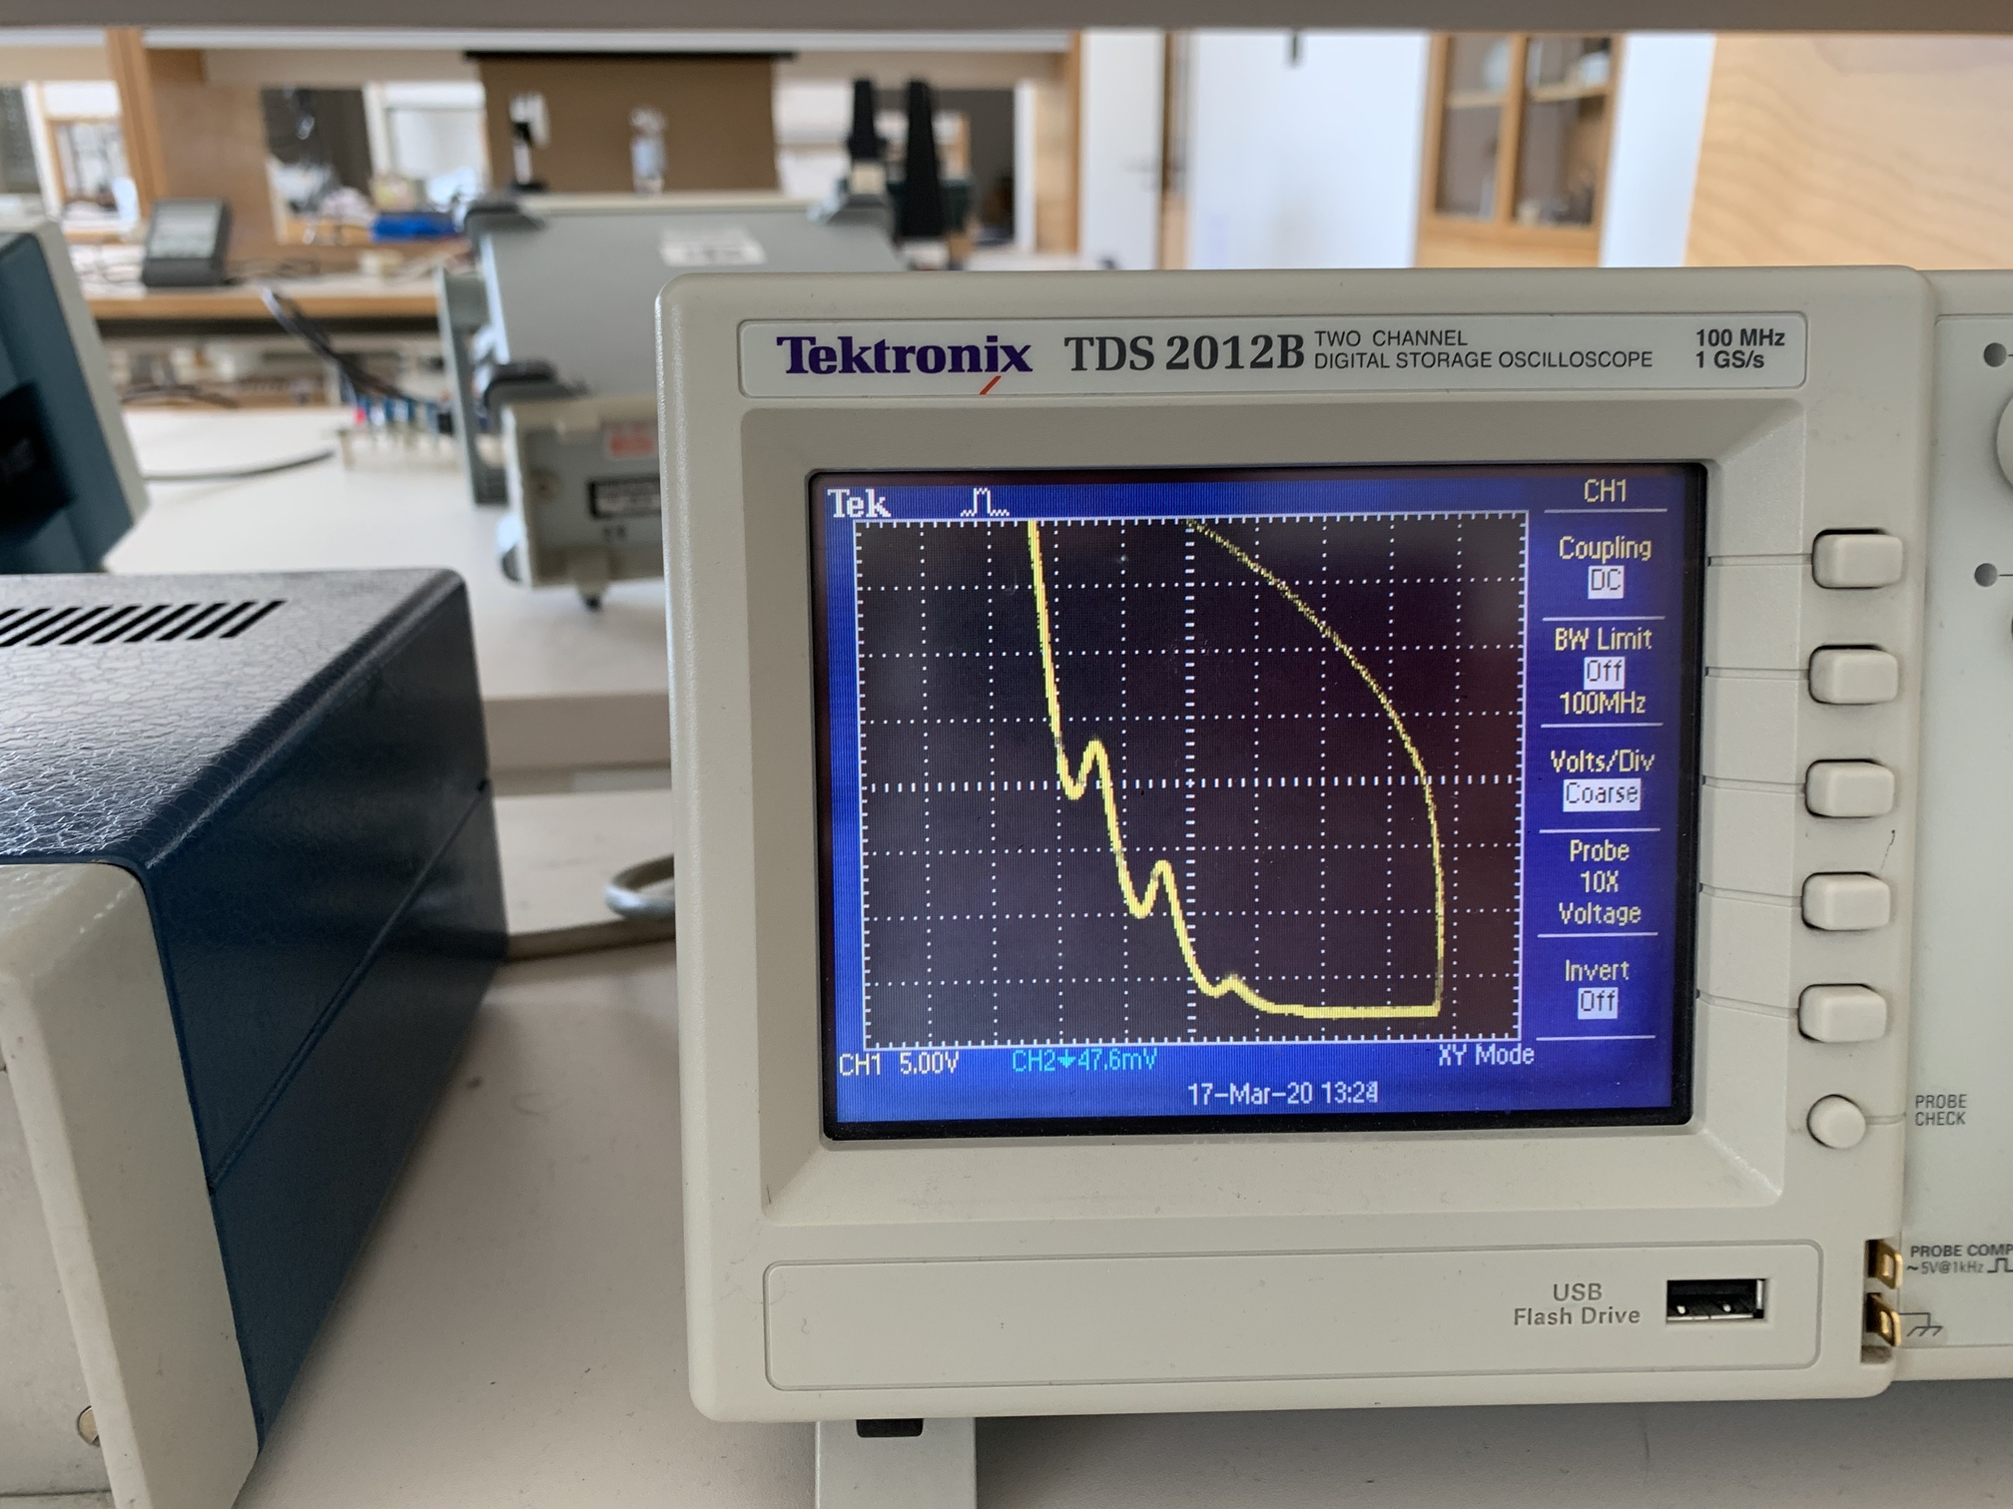

$T=26°C$

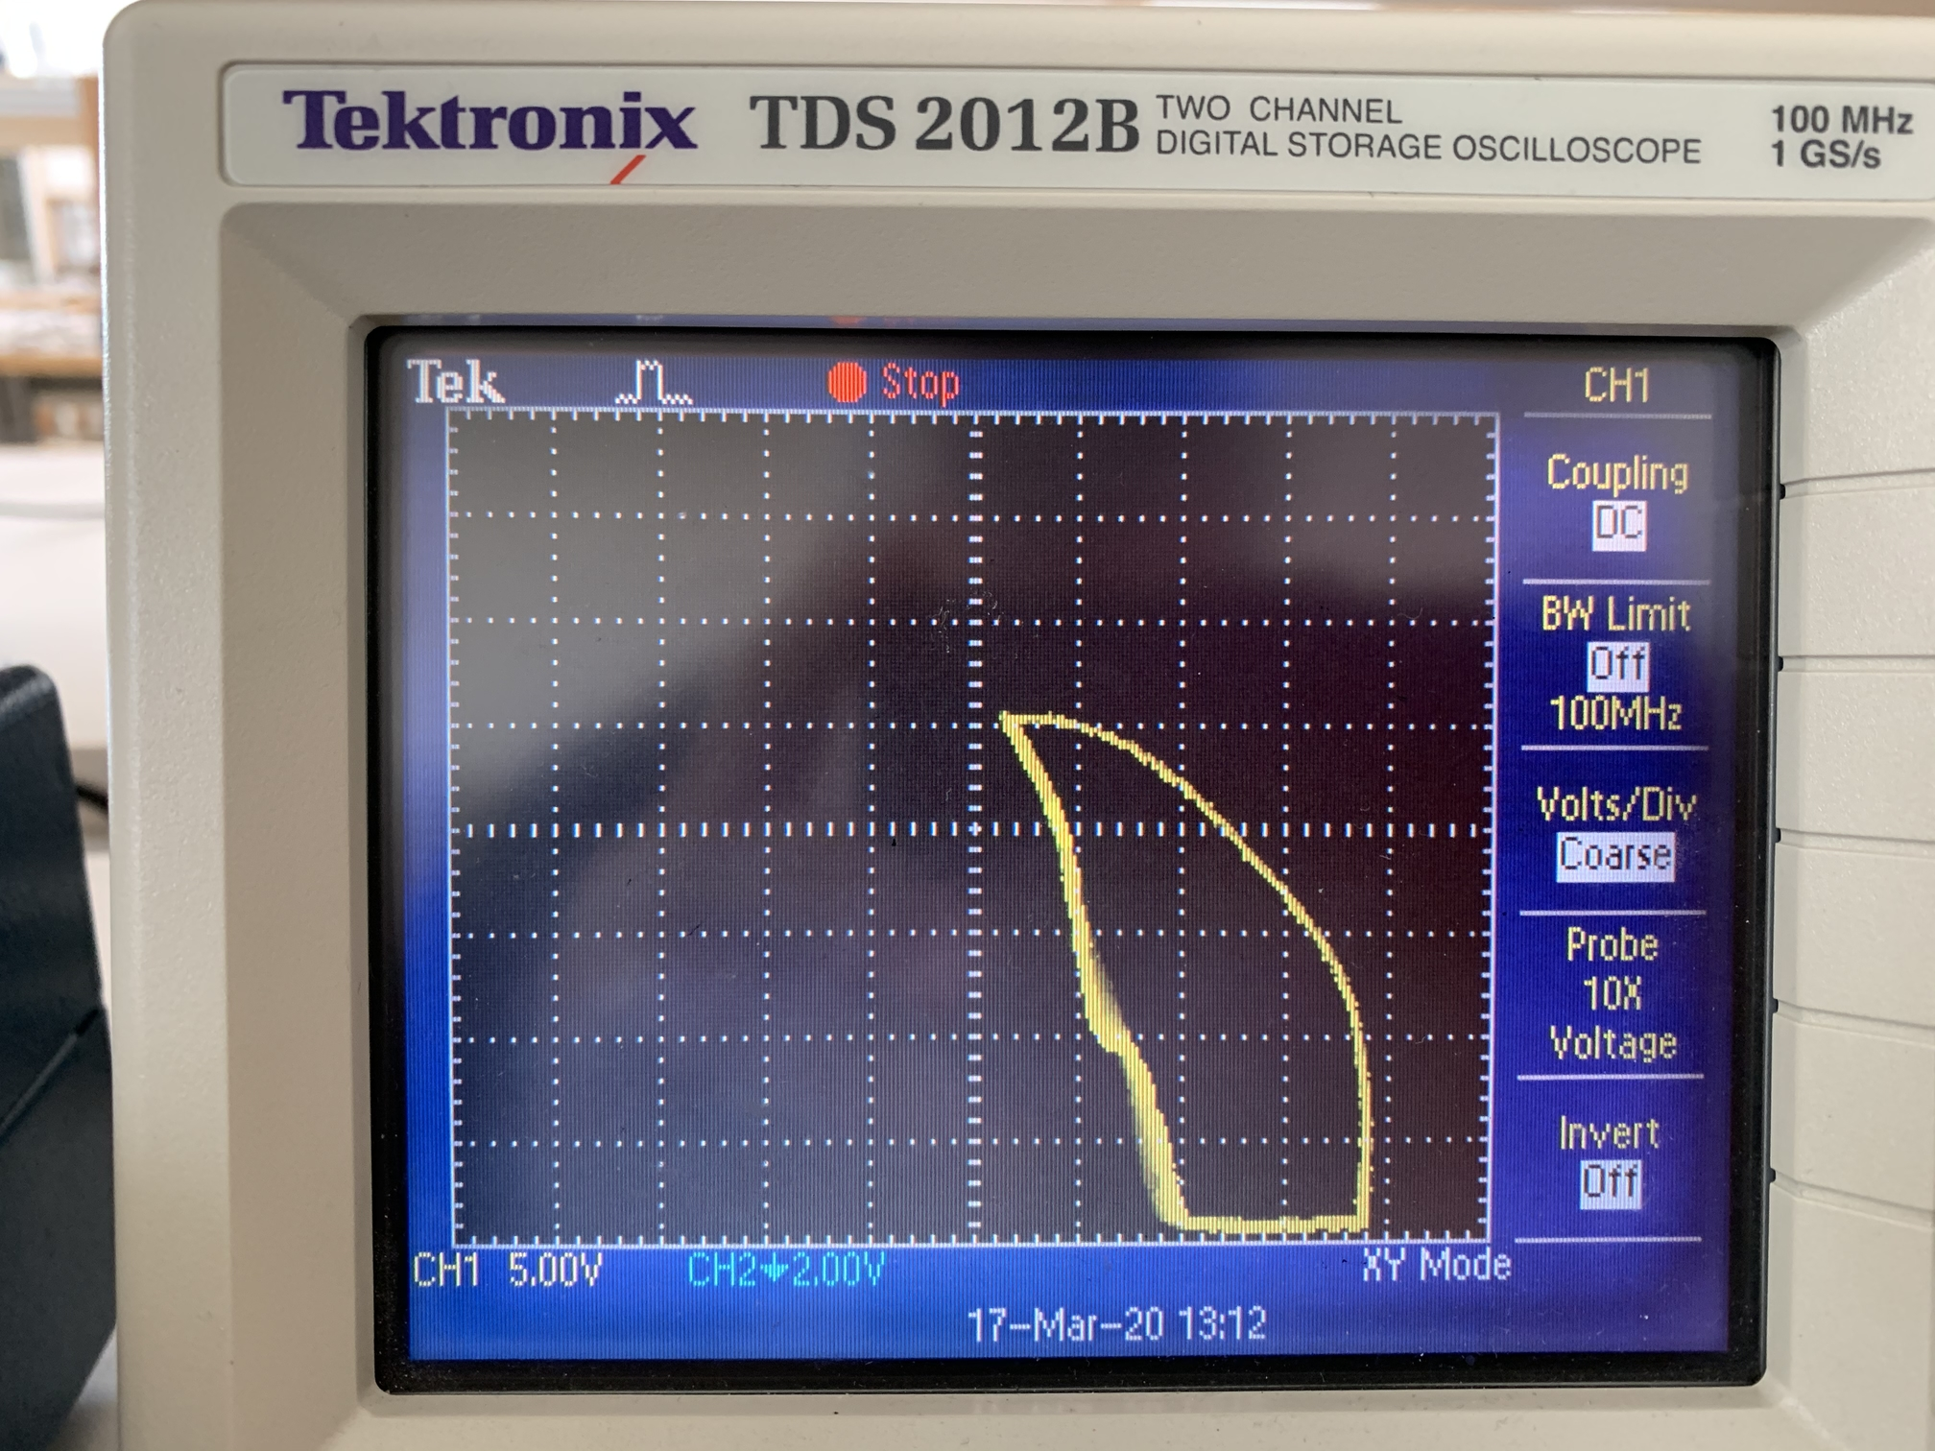

|  |  |  |  |
| --- | --- | --- | --- |
| **T = 180 °C** | | | |
|
| **n** | **U1,n [V]** | **dU1,n [V]** | **ΔU1,n[V]** |
| 1 | 4,5 | 0,5 | 4,5 |
| 2 | 9,5 | 0,5 | 5 |
| 3 | 13,5 | 0,5 | 4 |
| 4 | 18,5 | 0,5 | 5 |
| 5 | 23 | 0,5 | 4,5 |

|  |  |  |  |
| --- | --- | --- | --- |
| **T = 160°C** | | | |
|
| **n** | **U1,n [V]** | **dU1,n [V]** | **ΔU1,n[V]** |
| 1 | 4 | 0,5 | 4 |
| 2 | 9 | 0,5 | 5 |
| 3 | 14,5 | 0,5 | 5,5 |
| 4 | 19 | 0,5 | 4,5 |

|  |  |
| --- | --- |
| **Razlike maksimumov  vseh meritev** | |
|
| **N** | **ΔU1,n[V]** |
| 1 | 4,5 |
| 2 | 5 |
| 3 | 4 |
| 4 | 5 |
| 5 | 4,5 |
| 6 | 4 |
| 7 | 5 |
| 8 | 5,5 |
| 9 | 4,5 |
| 10 | 4 |
| 11 | 5 |
| 12 | 5 |
| 13 | 4 |
| 14 | 5 |
| 15 | 5,5 |
| 16 | 5 |
| 17 | 6 |
| **Value** | 4,8 |

|  |  |  |  |
| --- | --- | --- | --- |
| **T = 140°C** | | | |
|
| **n** | **U1,n [V]** | **dU1,n [V]** | **ΔU1,n[V]** |
| 1 | 4 | 0,5 | 4 |
| 2 | 9 | 0,5 | 5 |
| 3 | 14 | 0,5 | 5 |
| 4 | 18 | 0,5 | 4 |

|  |  |  |  |
| --- | --- | --- | --- |
| **T = 120°C** | | | |
|
| **n** | **U1,n [V]** | **dU1,n [V]** | **ΔU1,n[V]** |
| 1 | 5 | 0,5 | 5 |
| 2 | 10,5 | 0,5 | 5,5 |
| 3 | 15,5 | 0,5 | 5 |

|  |  |  |  |
| --- | --- | --- | --- |
| **T = 26°C** | | | |
|
| **n** | **U1,n [V]** | **dU1,n [V]** | **ΔU1,n[V]** |
| 1 | 6 | 0,5 | 6 |